Multiply Premier
New R1,000 Cashback Campaign
Author: Nonjabulo Msomi
Nonjabulo.msomi@multiply.co.za
Prepared by:
Date | Author: | Version: | Change Reference:
06 January 2022 | Nonjabulo Msomi | 1.0 | Draft
24 January 2022 | Nonjabulo Msomi | 1.1 | Changes to the campaign as per session with Dirk
25 January 2022 | Nonjabulo Msomi | 1.2 | Changes to the campaign as per comments and suggestions from Dirk
27 January 2022 | Nonjabulo Msomi | 1.3 | Addition of user stories as per requirments
31 January 2022 | Nonjabulo Msomi | 1.4 | Changes to the campaign as per alignment session with Dirk, Zanie and Susan

Document Approval:
Name | Date: | Designation: | Signature:
Anneline Cross |  | Head: Multiply Premier and Service
Dirk Nel |  | Portfolio Manager

Table of Contents

Background Information 3
Inclusions 3
Exclusions 3
Dependencies 3
Pre-Conditions 3
Business Rules 4
Functional Requirements (front-end) 4
Functional Requirements (back-end) 5
Automated Communications 6
CCF (front-end) 7
User stories: App (front-end) 8
User stories: Automated Comms 14
User stories: CCF (Front-end) 17
Stakeholder list 24

BACKGROUND INFORMATION:
The Multiply Rewards Program, in pursuit of an increased client engagement from new joining members, is revamping and will be running a new R1,000 cashback campaign.
This is an acquisition initiative and is therefore looking at creating an enticing campaign for new joiners in order to drive client engagement, more product uptake from the other respective product offerings and ultimately client retention.
Considering the above-mentioned initiative, we must create and update the current Momentum Multiply App and CCF respectively, in order to display and run the new R1,000 campaign for new joiners effectively.

Inclusions:
- Multiply app changes for both:
- Back-end App configurations
- CCF Changes for both
- Back- end web configurations
- Front end screen customization
- Automated communications to clients
Exclusions:
- Multiply App Front-end screen design and customization
Dependencies:
- Solution to check and ensure that members who belonged to the previous R1,000 cashback campaign and received cash payouts are excluded from this campaign
- Solution to ensure that the members on the current R1,000 Cashback campaign should still see the campaign they are part of (New Contracts before 1 February 2022)
- Solution to check that members with a previously cancelled contract are excluded from this campaign
- Testing of payments for each cashback reward upon successful completion for each milestone.
- New development build required for the below challenges/tasks in the respective milestones:
  - Earn your first reward (cashback at either PnP, Dis chem, Clicks).
  - Earn and redeem your first weekly win treat
  - Redeem you first monthly win treat
- All e-mail communication to be sent to members, e-mail templates and content for each

Pre-conditions:
- New Joining Premier (principal) member
- New Joining Premier member as of Date: 1 February 2022
- New Joining Premier member has a client ID as per new profile created

Business Rules:
- Only new Premier joining (principal) members as of 1 February 2022 are eligible for the campaign
- The campaign with run for a duration of 1 February 2022 - 31 December 2022 (Configurable)
- The challenges/tasks are grouped into 3 different milestones
- Each milestone constitutes several challenges/tasks that must be completed and will trigger the following milestone:
  - Milestone 1 – 6 tasks/challenges
  - Milestone 2 – 3 tasks/challenges
  - Milestone 3 – 2 tasks/challenges
- New joiner will kick off Milestone 1 challenges/tasks and so forth
- A member must complete all the challenges/tasks in each milestone in order to move onto the following milestone challenges and so forth
  - A reward will be awarded once all the challenges/tasks from each respective milestone have been completed
- A member will have a period of three months to complete the respective tasks/challenges for each milestone
- Automated communication via e-mail will be sent to members in the below instances:
- New Joiner – at initial start of the campaign
- Progress during the milestone challenges/tasks (e.g. how many challenges/tasks remaining in order to complete the milestone)
- Completion of each milestone (e.g. all the challenges/tasks have been completed in the milestone and moving onto the following milestone (if applicable))
- Completion of each milestone for cashback reward to be earned
- A member can only partake in one active campaign during the duration of a campaign
- A member that was part of the previous R1,000 cashback campaign and received cashback reward is not eligible to partake in this this new campaign

Functional Requirements (Front-end):
Number: | Requirement: | Description:
1. | Create the ability to display the new R1000 Cashback campaign (Contest Card) on the Multiply app homepage | The system must be able to dynamically display the new R1000 Cashback campaign on the Multiply app homepage for all members that are eligible for the campaign
1.1 | Create the ability to not display the new R1000 Cashback campaign (Contest Card) on the Multiply app homepage | The system must be able to not display the new R1000 Cashback campaign on the Multiply app homepage for all members that are eligible for the campaign once the campaign duration is over.
2. | Create the ability to display the campaign details on the contest card/section | The system must have the ability to dynamically display the new campaign details on the contest card section
3. | Create the ability to display the 3 different milestones required (depending on each members’ progress) for the member to complete | The system must display one milestone and all the applicable tasks/challenges at a time, depending on the member’s progress:  - Green ticked challenges (completed)  - Grey displayed challenges (not completed and still outstanding)
4. | Create the ability track and display the User’s activity/progress | The system must be able to display the member’s current:  - milestone,  - outstanding tasks/challenges in each milestone
5. | Create the ability to display the duration of the campaign | The system must be able to display the campaign’s duration period:  - start and end date.
6. | Create the ability to display the count down for the campaign | The system must be able to display the countdown of the campaign:  - the number of days remaining
7. | Create an ability to display the reward associated with the campaign | The system must be able to display the details of the cashback reward for each applicable milestone
8. | Create the ability to display the completed dial, for each milestone, once all the tasks/challenges have been completed | The system must be able to display the “All tasks/challenges Complete” dial once:  - all the challenges have been completed, for each milestone
9. | Create the ability to dynamically display the completed text under the dial once all the milestones and applicable challenges have been completed. | The system must be able to able to display the below applicable Wording once:  - each milestone has been completed  “Challenge completed: You have successfully completed the challenge and earned R250/R250/R500 (select one) in cashbacks”
10. | Create the ability to display to the trophy image pop-up if a member has completed all the challenges within the different milestones | The system must be able to display the below wording as a pop-up on the app homepage once all the challenges from each milestone have been completed:  - “Challenge complete! You have successfully completed all the tasks of the challenge; you will be credited with R250/R250/R500 (select one) in the next week”
11. | Create the ability to display the Ts & Cs of the campaign on the challenge and rewards screen | The system must be able to display the applicable terms and conditions for the campaign:  - Clickable hyperlink

Functional Requirements (Back-end):
Number: | Requirement: | Description:
1. | The Back End must pass the campaign description and contest date/s to the front-end | The system must be able to pass the campaign description and the duration period that will be displayed on the front-end
2. | The Back End must pass the campaign count down timer for the campaign | The system must be able to pass the milestone countdown timer in DD format e.g. (13 days remaining) and when the count is less that one day remaining, to display it as “last day”
4. | The Back End must aggregate the challenges/tasks completed for each challenge/task and send the indicators in format: “X/Y” so that the frontend can display “X/Y” in the dialer. | The system must be able to pass progress/completed indicators so that are clearly displayed on the front-end dialer  e.g. 2/6 tasks completed (Milestone 1), 2/3 tasks completed (Milestone 2) and so forth / All tasks complete
5. | The Back End must pass the list of all tasks/challenges that the members must complete for each milestone | The system must be able to list all the applicable challenges for each milestone and categorized accordingly depending on the member’s progress.
6. | The Back End must pass the disclaimer copy on the applicable challenges | The system must be able to display all the applicable disclaimer copies for each challenge respectively
7. | The Back End must pass the different challenges associated with the campaign | The system must be able to display all the applicable challenges for each milestone for the complete campaign and categorized accordingly
8. | The Back End must keep a history of all the challenges for each milestone and campaign | The system must be able to keep a transactional history of all the tasks/challenges within each milestone and ultimately the complete campaign
9. | The Back End must trigger the event for a reward payment when all the challenges/tasks for each milestone have been completed within the campaign time duration | The system must be able to trigger the event for the R250/R250/R500 cashback reward when all the tasks for each milestone have been completed withing the campaign duration period  - R250/R250/R500 cashback reward must be paid when the event for the reward has been sent (each separate milestone)

Automated Communications:
Number: | Requirement: | Description:
1. | Create the ability to send automated communications to members that are eligible for the campaign | The system must be able to automatically send out e-mail communications to new joiners that qualify for the campaign
2. | Create the ability to send automated e-mails reminders to members on the current progress/activity for each milestone | The system must be able to automatically send out e-mail communications to members as reminders of the current progress for each milestone within a specific time period  - A specific time period must be stated if a milestone is not completed for each member (to be confirmed)
3. | Create the ability to send automated e-mail reminders to members for each milestone once all the tasks have been completed and:  - the reward earned,  - the member is moving onto the next milestone (applicable to milestone 1 & 2) | The system must be able to automatically send out e-mail communications to members upon completion for each milestone when all tasks have been completed and:  - the reward earned  - the member is moving onto the next milestone (applicable to milestone 1 & 2)

CCF (Front-end):
Number: | Requirement: | Description:
1. | Create the ability to display the contest and rewards image/icon on the CCF dashboard | The system must display the contest and rewards image icon the CCF dashboard and when clicked, will display the contest and rewards dashboard
2. | Create the ability to display the contest and rewards dashboard on the Contest and Rewards page | The system must display the contest and rewards dashboard when the contest and rewards image has been clicked, with the below tabs:  - Challenge tab  - Rewards tab
3. | Create the ability to display the clickable terms & conditions hyperlink on the rewards tab of the Contest and Rewards dashboard | The system must:  - display the clickable terms & conditions hyperlink on the Rewards tab,  - once the clickable hyperlink has been clicked, display the applicable terms and conditions for the active campaign on the Rewards tab
4. | Create the ability to display clickable (right-aligned) dropdown buttons on each task/challenge listed on the challenge tab on the contest and reward dashboard | The system must:  - display clickable (right-aligned) dropdown buttons on each task/challenge listed on the challenge tab  - once the clickable buttons have been clicked, display the task/challenge details on the challenge tab
5. | Create the ability to display the contest and rewards dashboard if there is:  - no active campaign or  - the campaign has ended | The system must display the contest and rewards image icon on the CCF dashboard, and when clicked, will:  - display the contest and rewards dashboard and the dashboard screen will not be populated with any campaign details

User stories: APP (Front-end)
Number | User Story | Acceptance Criteria: | Screenshots:
RE-ID 1. | As a new Premier member, I want to view the new R1000 Cashback campaign on the Contest Card on the Multiply app homepage so that I know that I am eligible for the campaign | - The new member must be eligible for the campaign:  - Not have been part of a previous campaign and received payment for a cashback reward  - Previously cancelled contract  - Must be a Principal member  - The new member must have joined Multiply Premier from 1 February 2022  - The member must log onto the app using their newly created credentials: username and password  - The member must successfully log onto the Multiply app  - The new R1,000 cashback campaign must be displayed on the Contest Card on the homepage | 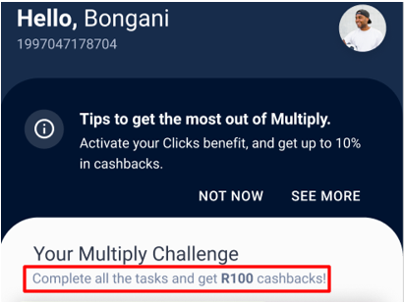
RE-ID 1.1 | As a new Premier member, I want to view the removed R1,000 Cashback campaign on the Contest Card on the Multiply app homepage so that I know that the campaign is over | - After the contest duration is over, the app must not display the contest card anymore.  - After the 31st December 2022, the contest card and campaign details must no longer be displayed in the app | 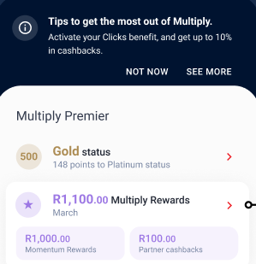
RE-ID 2. | As a new Premier member, I want to view the new R1,000 Cashback campaign details on the Contest Card section on the Multiply app homepage so that I know that I can partake in the campaign | - The new member must be successfully logged onto the Multiply app  - The new R1,000 cashback campaign details must be displayed on the Contest Card on the homepage  - Your multiply challenge: New Multiply members who complete all the tasks will earn a R250/250/R500 OR a cumulative R1,000 in cashbacks  - Progress dialer for tasks/Challenges completed  - Duration of the campaign (start and end date)  - Number of days remaining to complete the all the tasks for the challenge | 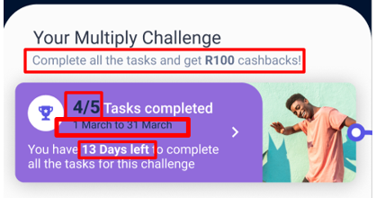
RE-ID 3. | As a new Premier member, I want to view the 3 different milestones on the Multiply Challenge section so that I know which tasks/challenges must be completed in order to complete the Milestones for | - The member must be on the Multiply challenge section  - The tasks/challenges must be displayed as one milestone/for each milestone grouping at a time depending on the member’s progress.  - The below tasks/challenges must be listed and displayed into the below categories as per below:  - Challenges: for Milestone 1  - Download the Momentum Multiply app  - Complete the Health and activity questionnaire  - Complete the Safety Score questionnaire  - Complete the Financial wellness questionnaire  - Earn your first Active Day  - Link / activate at least one Partner (PnP, Dischem or Clicks)  - Challenges: (for Milestone 2)  - Earn your first reward (cashback at either PnP, Dischem, Clicks)  - Earn and redeem your first weekly win treat  - Go for a Health Assessment  - Challenges: (for Milestone 3)  - Earn and redeem your first weekly win treat  - Go for a Fitness Assessment  - The outstanding (not yet completed) challenges/tasks must be listed and displayed with a left aligned grey tick dial next to the challenge/task name  - The completed (completed) challenges/tasks must be listed and displayed and with a left aligned green tick dial next to the challenge/task name | 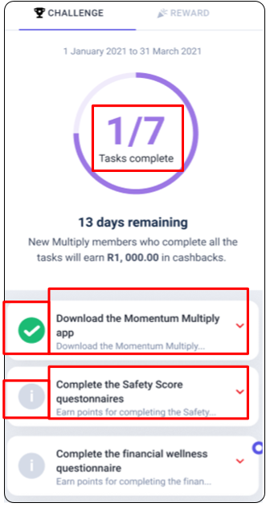
RE-ID 4. | As a new Premier member, I want to track my activity/progress so that I know which tasks/challenges are still outstanding for each milestone | - The app must update the activity progress bar with every login and refresh  - The outstanding (not yet completed) challenges/tasks must be listed and displayed with a left aligned grey tick dial next to the challenge/task  - The completed (completed) challenges/tasks must be listed and displayed with a left aligned green tick dial  - The number of tasks completed dialer must display the number of tasks completed versus the number of tasks outstanding e.g. 2/6 Tasks complete (milestone 1) and 1/3 tasks complete (milestone 2) and so forth  - On the Contest card section on the homepage  - On the Multiply Challenges section (challenge tab) | 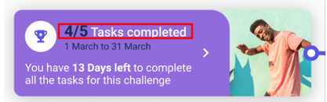
RE-ID 5. | As a new Premier member, I want to view duration of the campaign so that I know the start and end date for the campaign | - The member must be on the Contest card /Multiply challenge section  - The start date and date must be displayed as:  - 01 February 2022 to 31 December 2022 on  - On the Contest card section on the homepage  - On the Multiply Challenge section (challenge tab) | 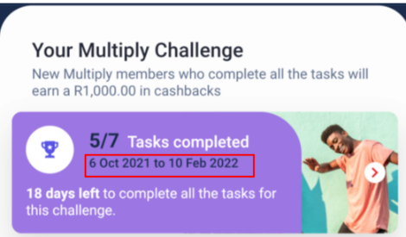  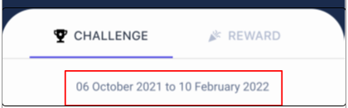
RE-ID 6. | As a new Premier member, I want to view countdown of the campaign so that I know how many days are remaining for the campaign | - The app must clearly display the number of days remaining before the campaign is over  - The member must be on the app homepage and the below must be displayed on the contest card:  - “__ days left to complete all the tasks for this challenge” depending on progress of the campaign  - “Last day to complete all the tasks for this challenge” if the count is less than one day  - The member must be on the app multiply challenge section and the below wording must be displayed (Below the number of tasks completed dialer):  - “__ days remaining” | 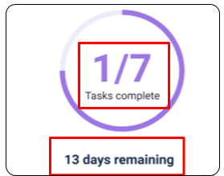  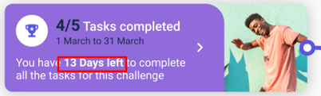
RE-ID 7. | As a new Premier member, I want to view rewards associated with the campaign so that I know which reward I will earn for completing each milestone in the campaign | - The member must be on the app homepage and the below must be displayed on the contest card:  - “New Multiply members who complete all the tasks will earn a cumulative total of R1,000 in cashbacks”  - The member must be on the app multiply challenge section and the below wording must be displayed below the countdown wording:  - “New Multiply members who complete all the tasks will earn a cumulative total of R1,000 OR R250/R250/R500 (select one) in cashbacks | 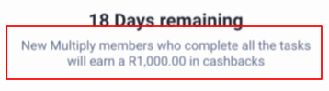  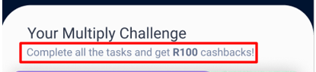
RE-ID 8. | As a new Premier member, I want to view completed dial for each milestone so that I know I have no outstanding tasks for the applicable milestone | - The member must be on the app multiply challenge section and below the duration period, the below must be displayed in a dial:  - “All tasks completed” | 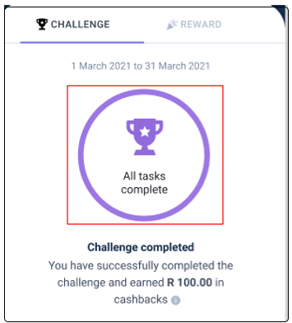
RE-ID 9. | As a new Premier member, I want to view completed text under the completed dial so that I know that I have completed all the applicable tasks for each milestone | - The member must be on the app multiply challenge section and below the dial, the below wording must be displayed in a dial:  - “Challenge completed: You have successfully completed the challenge and earned R250/R250/R500 (select one) in cashbacks” | 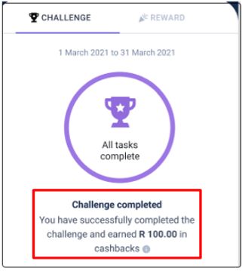
RE-ID 10. | As a new Premier member, I want to view trophy image and wording as pop-up so that I know I have completed the campaign | - The member must be on the app homepage and the below image and wording must be displayed:  - Trophy  - “Challenge complete! You have successfully completed all the tasks of the challenge; you will be credited with R250/R250/R500 (select one) in the next week” | 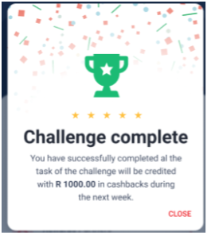
RE-ID 11. | As a new Premier member, I want to view the Terms & Conditions so that I know the applicable terms and condition for the campaign | - The member must be on the app multiply challenge section page and below the terms and conditions heading,  - The terms and conditions (bottom aligned) clickable hyperlink must be displayed:  - View terms & conditions  - The member must be on the Rewards section page and at the bottom of the page,  - The terms and conditions (bottom aligned) clickable hyperlink must be displayed:  - Terms & conditions  - The hyperlinks (View terms & conditions + Terms & conditions) must be  - clickable and  - once clicked, it must display the applicable terms & conditions | 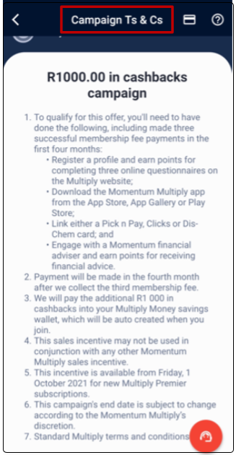  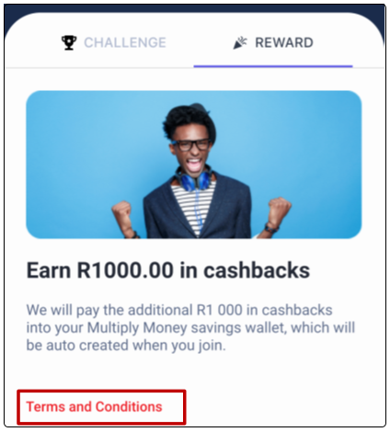  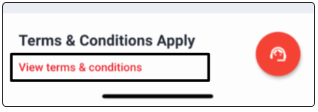
User stories: Automated Comms
Number | User Story | Acceptance Criteria: | E-mail template (To be Confirmed)
RE-ID 1. | As a new Premier member, I want to receive the new R1000 Cashback campaign e-mail that I know that I am eligible for the campaign | - The new member must be eligible for the campaign:  - Not have been part of a previous campaign and received payment for a cashback reward  - Not have a previously cancelled contract  - Must be a Principal member  - The new member must have joined Premier from 1 February 2022  - The new member must have a valid e-mail address added to their profile  - The member must receive an onboarding e-mail (Template and wording to be confirmed) of the new R1,000 cashback campaign on:  - Date: 1 February 2022  - Time: 00:00:00 | Beginning of Milestone 1:  - Trigger: New joining member from 1 February 2022  - Subject: New R1,000 Cashback campaign onboarding  - E-mail contents: Well done – you have been onboarded successfully onto the brand new and exciting campaign as part of your new Multiply membership. To get you excited, please ensure you do the following for your first cashback pay-out:  - Download the Momentum Multiply app  - Complete the Health and activity questionnaire  - Complete the Safety Score questionnaire  - Complete the Financial wellness questionnaire  - Earn your first Active Day  - Link / activate at least one Partner (PnP, Dischem or Clicks)
RE-ID 2. | As a new Premier member, I want to receive the new R1,000 Cashback campaign reminder e-mail/s so that I know that for each milestone:  - How many tasks have been completed versus the number of outstanding tasks | - The new member must be partaking in the current campaign and is either on (progress):  - Milestone 1/ Milestone 2/ Milestone 3  - The new member must have > 1 task/s outstanding for each milestone within a 3 months period  - The member must receive an e-mail (Template and wording to be confirmed) of the new R1,000 cashback campaign reminder of their current tasks progress:  - Date: 1 March 2022 (Monthly)  - Time: 00:00:00 | - Trigger: Outstanding tasks in each milestone for a specific time period  - Subject: New R1,000 Cashback campaign progress  - E-mail contents: Please note that you have completed 4/6 tasks (depending on the milestone), you will need to complete the outstanding tasks by 30 March in order to receive your cashback reward.
RE-ID 3 | As a new Premier member, I want to receive the new R1,000 Cashback campaign successful tasks completion e-mail/s so that I know that for each milestone:  - I have completed all the tasks  - I am moving onto the next milestone (applicable to milestone 2 & 3) | - The new member must be partaking in the current campaign and is either on (progress):  - Milestone 1/ Milestone 2/ Milestone 3  - The new member must have completed all the tasks from the preceding milestone/s  - The new member must be automatically onboarded onto the following milestone (applicable to milestone 2 & 3)  - The member must receive an e-mail (Template and wording to be confirmed) of the new R1,000 cashback campaign completion of all the tasks in their current milestone:  - Date: 15 February 2022  - Time: 00:00:00 | Beginning of Milestone 2:  - Trigger: All tasks successfully completed for milestone 1  - Subject: New R1,000 Cashback campaign tasks completed  - E-mail contents: Well done – you have successfully completed the first set of requirements. Now, let’s get excited with even more e exciting actions to receive your next cashbacks pay-out:  - Earn your first reward (cashback at either PnP, Dischem, Clicks)  - Earn and redeem your first weekly win treat  - Go for a Health Assessment  Beginning of Milestone 3:  - Trigger: All tasks successfully completed for milestone 2  - Subject: New R1,000 Cashback campaign tasks completed  E-mail contents: Well done – you have successfully completed the second set of requirements. Now for the last and final set of exciting actions to receive your final and biggest cashbacks pay-out yet:  - Earn and redeem your first weekly win treat  - Go for a Fitness Assessment
RE-ID 3.1 | As a new Premier member, I want to receive the new R1,000 Cashback campaign completed e-mail/s so that I know that for each milestone:  - I have completed all the tasks,  - the reward has been earned | - The new member must be partaking in the current campaign and is either on (progress):  - Milestone 1/ Milestone 2/ Milestone 3  - The new member must have completed all the tasks for each milestone  - The new member must earn and be paid the applicable cashback reward depending on progress:  - Completion of Milestone 1 – R250  - Completion of Milestone 2 – R250  - Completion of Milestone 3 – R500  - The member must receive an e-mail (Template and wording to be confirmed) of the new R1,000 cashback campaign completion of each milestone:  - Date: 16 February 2022  - Time: 00:00:00 | End of Milestone 1:  - Trigger: All activities successfully completed for milestone 1  - Subject: New R1,000 Cashback campaign milestone completed  - E-mail contents: Congratulations on successfully completing all the tasks for the first leg of this campaign! Your R250 cashbacks will be paid into your savings wallet.  End of Milestone 2:  - Trigger: All activities successfully completed for milestone 2  - Subject: New R1,000 Cashback campaign milestone completed  - E-mail contents: Congratulations on successfully completing all the requirements for the second leg of this campaign! Your R250 cashbacks will be paid into your savings wallet.  End of Milestone 3:  - Trigger: All activities successfully completed for milestone 2  - Subject: New R1,000 Cashback campaign milestone/challenge completed  - E-mail contents: Congratulations on successfully completing all the requirements for this campaign! Your final R500 cashbacks will be paid into your savings wallet.

User stories: CCF (Front-end)
Number | User Story | Acceptance Criteria: | Screenshots:
RE-ID 1. | As a Services Agent, I want to view the contest and rewards image/icon on the CCF dashboard so that I know that there is an active campaign that is currently ongoing. | - The Client services agent must be:  - logged onto their CCF profile  - on the CCF dashboard and must see the contest and rewards image/icon  - must be able to click on the rewards image icon the CCF dashboard and when clicked, it must display the contest and rewards dashboard | - Please see Figure 1 below
RE-ID 2. | As a Services Agent, I want to view the contest and rewards dashboard on the Contest and rewards page so that I can see the details of the client’s active campaign | - The client services agent must be on the contest and rewards dashboard and must be:  - Client log-on details  - able to view the contest and rewards dashboard  - able to view the dropdown that will display the Client's contract composition (single/ family composition)  - The campaign details on the challenges tab and the rewards tab respectively (please refer to Front end user stories above) | - Please see Figure 2 below
Re-ID 3. | As a Services Agent, I want to view the Terms & Conditions so that I so that I know the applicable terms and condition for the campaign. | - The Services agent must be on the Contest and rewards dashboard, Rewards tab  - The terms and conditions (bottom aligned) clickable hyperlink must be displayed:  - Terms & conditions  - The hyperlink (Terms & conditions) must be  - clickable and  - once clicked, it must display the applicable terms & conditions | - Please see figure 3 below
RE-ID 4. | As a Services Agent, I want to view the clickable (right-aligned) dropdown buttons on each task/challenge listed on the challenge tab so that I know I can see the details pertaining to each task/challenge | - The Client services agent must be:  - on the Contest and rewards dashboard, Challenges tab  - Each task/challenge must have a clickable (right-aligned) dropdown button next to it  - The button, when clicked, must display the applicable task/challenge details  - Task description  - Actions | - Please see Figure 4 below
RE-ID 5. | As a Services Agent, I want to view the contest and rewards Dashboard on the CCF dashboard when there is no active campaign so that I know that  - there is no active campaign that is currently ongoing.  - the campaign has ended | - The Client services agent must be:  - logged onto their CCF profile  - on the CCF dashboard and must see the contest and rewards image/icon  - The client services agent must be able to click on the rewards image icon the CCF dashboard and when clicked, it must display the contest and rewards dashboard with no active campaign details | - Please see Figure 5 below

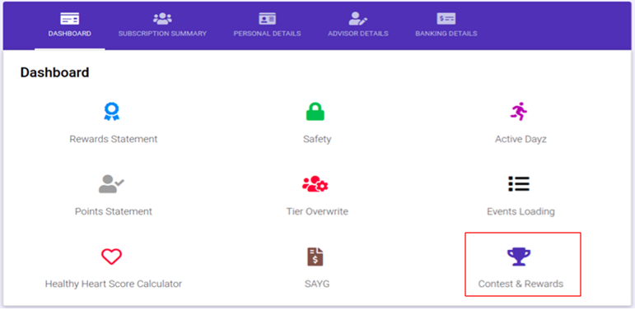
Figure 1: Displaying the Contest and rewards image on the CCF dashboard

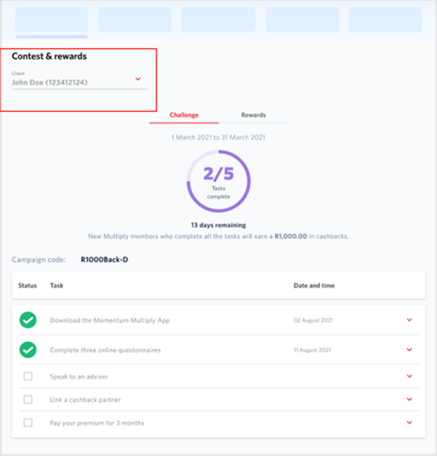
Figure 2: Displaying the Contest and Rewards dashboard and the active campaign details

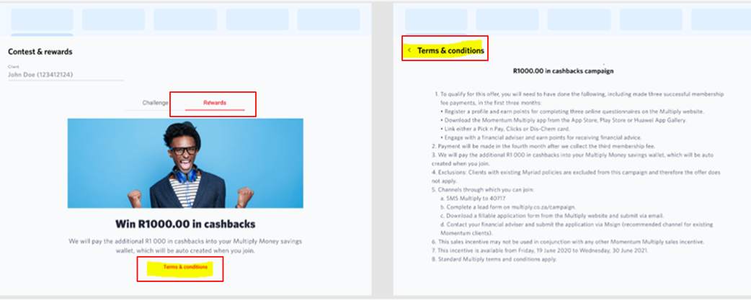
Figure 3: Displaying the terms and conditions of the campaign on the Rewards tab

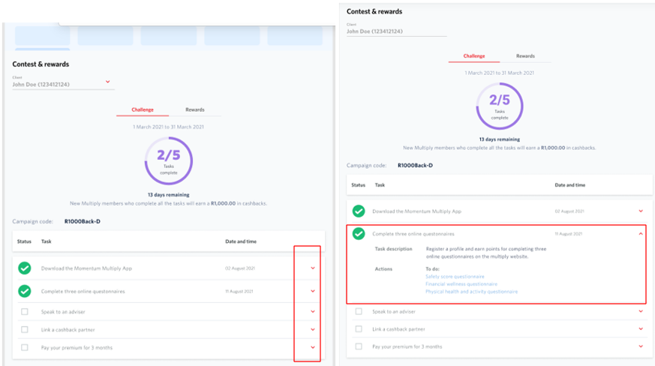
Figure 4: Displaying the Contest and Rewards dashboard task details
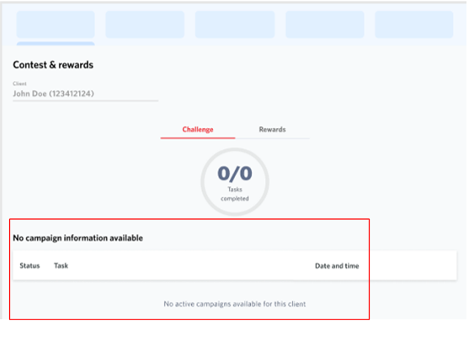
Figure 5: Displaying the Contest and Rewards dashboard with no active campaign

Stakeholder list
Stakeholder Name | Role | Business Unit | Contact Number | E-Mail Address
Dirk Nel | Product Owner: Multiply Premier | Wellness and Rewards | (012) 673 7878 | dirk.nel@multiply.co.za
Anneline Cross | Head: Multiply Premier and Service | Wellness and Rewards | (012) 673 7544 | anneline.cross@multiply.co.za
Nonjabulo Msomi | Business Analyst | Wellness and Rewards | 082 927 7390 | nonjabulo.msomi@multiply.co.za
Suretha Klue | Head: IT Business Analysis | Wellness and Rewards | (012) 684 4402 | suretha.klue@multiply.co.za
Susan Prinsloo | Business Analyst | Wellness and Rewards | (012) 671 8682 | susan.prinsloo@multiply.co.za
Lebogang Chipana | Programme Manager | Wellness and Rewards | (012) 684 4078 | lebogang.chipana@momentum.co.za
Zanie Kruger | Process Enablement Manager | Wellness and Rewards | (012) 671 8053 | zanie.kruger@multiply.co.za
Monageng Motsabi | Solutions Architect | Wellness and Rewards | (012) 671 8329 | motsabi.monageng@multiply.co.za
Isabel Sibeko | Systems Analyst | Business Enablement | (012) 684 4065 | isabel.sibeko@multiply.co.za

